Low & High-Fidelity Prototypes

1. Low-fidelity prototype of shopping bag

As I started sketching the shopping bag page, I wanted to design it to be simple and clear. There is a headline “Items in bag” indicating that the users are currently on the page of the shopping bag. Below the headline it shows the information of each added item, dividing the information into three columns – item name, item description, and price. Lastly, users can choose to either continue shopping or check out using the buttons at the bottom. My design choices are simply based on the functionality of the page – whether the information and features are necessary functions of a shopping bag.

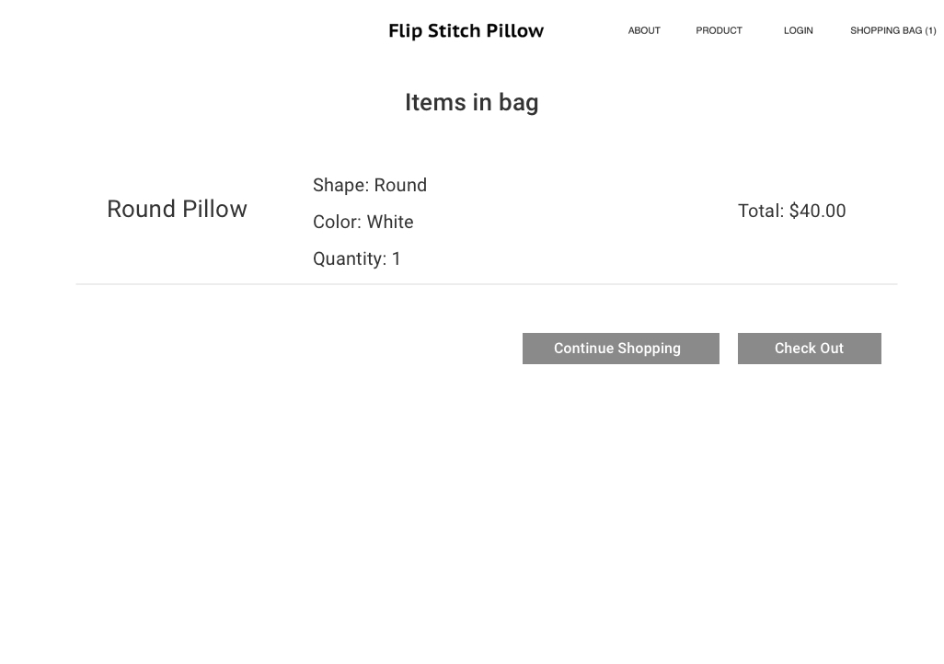

1. High-fidelity prototype of shopping bag

After the low-fi sketch, I moved onto designing the high-fidelity prototype. I kept the information I choose to put in the low-fi sketch – headline, item name, item description (color, shape, quantity), price, and action buttons. But for this high-fi screen, I played with information hierarchy to group different chunks of information together and separate them into different sections. I also added a picture of the item.

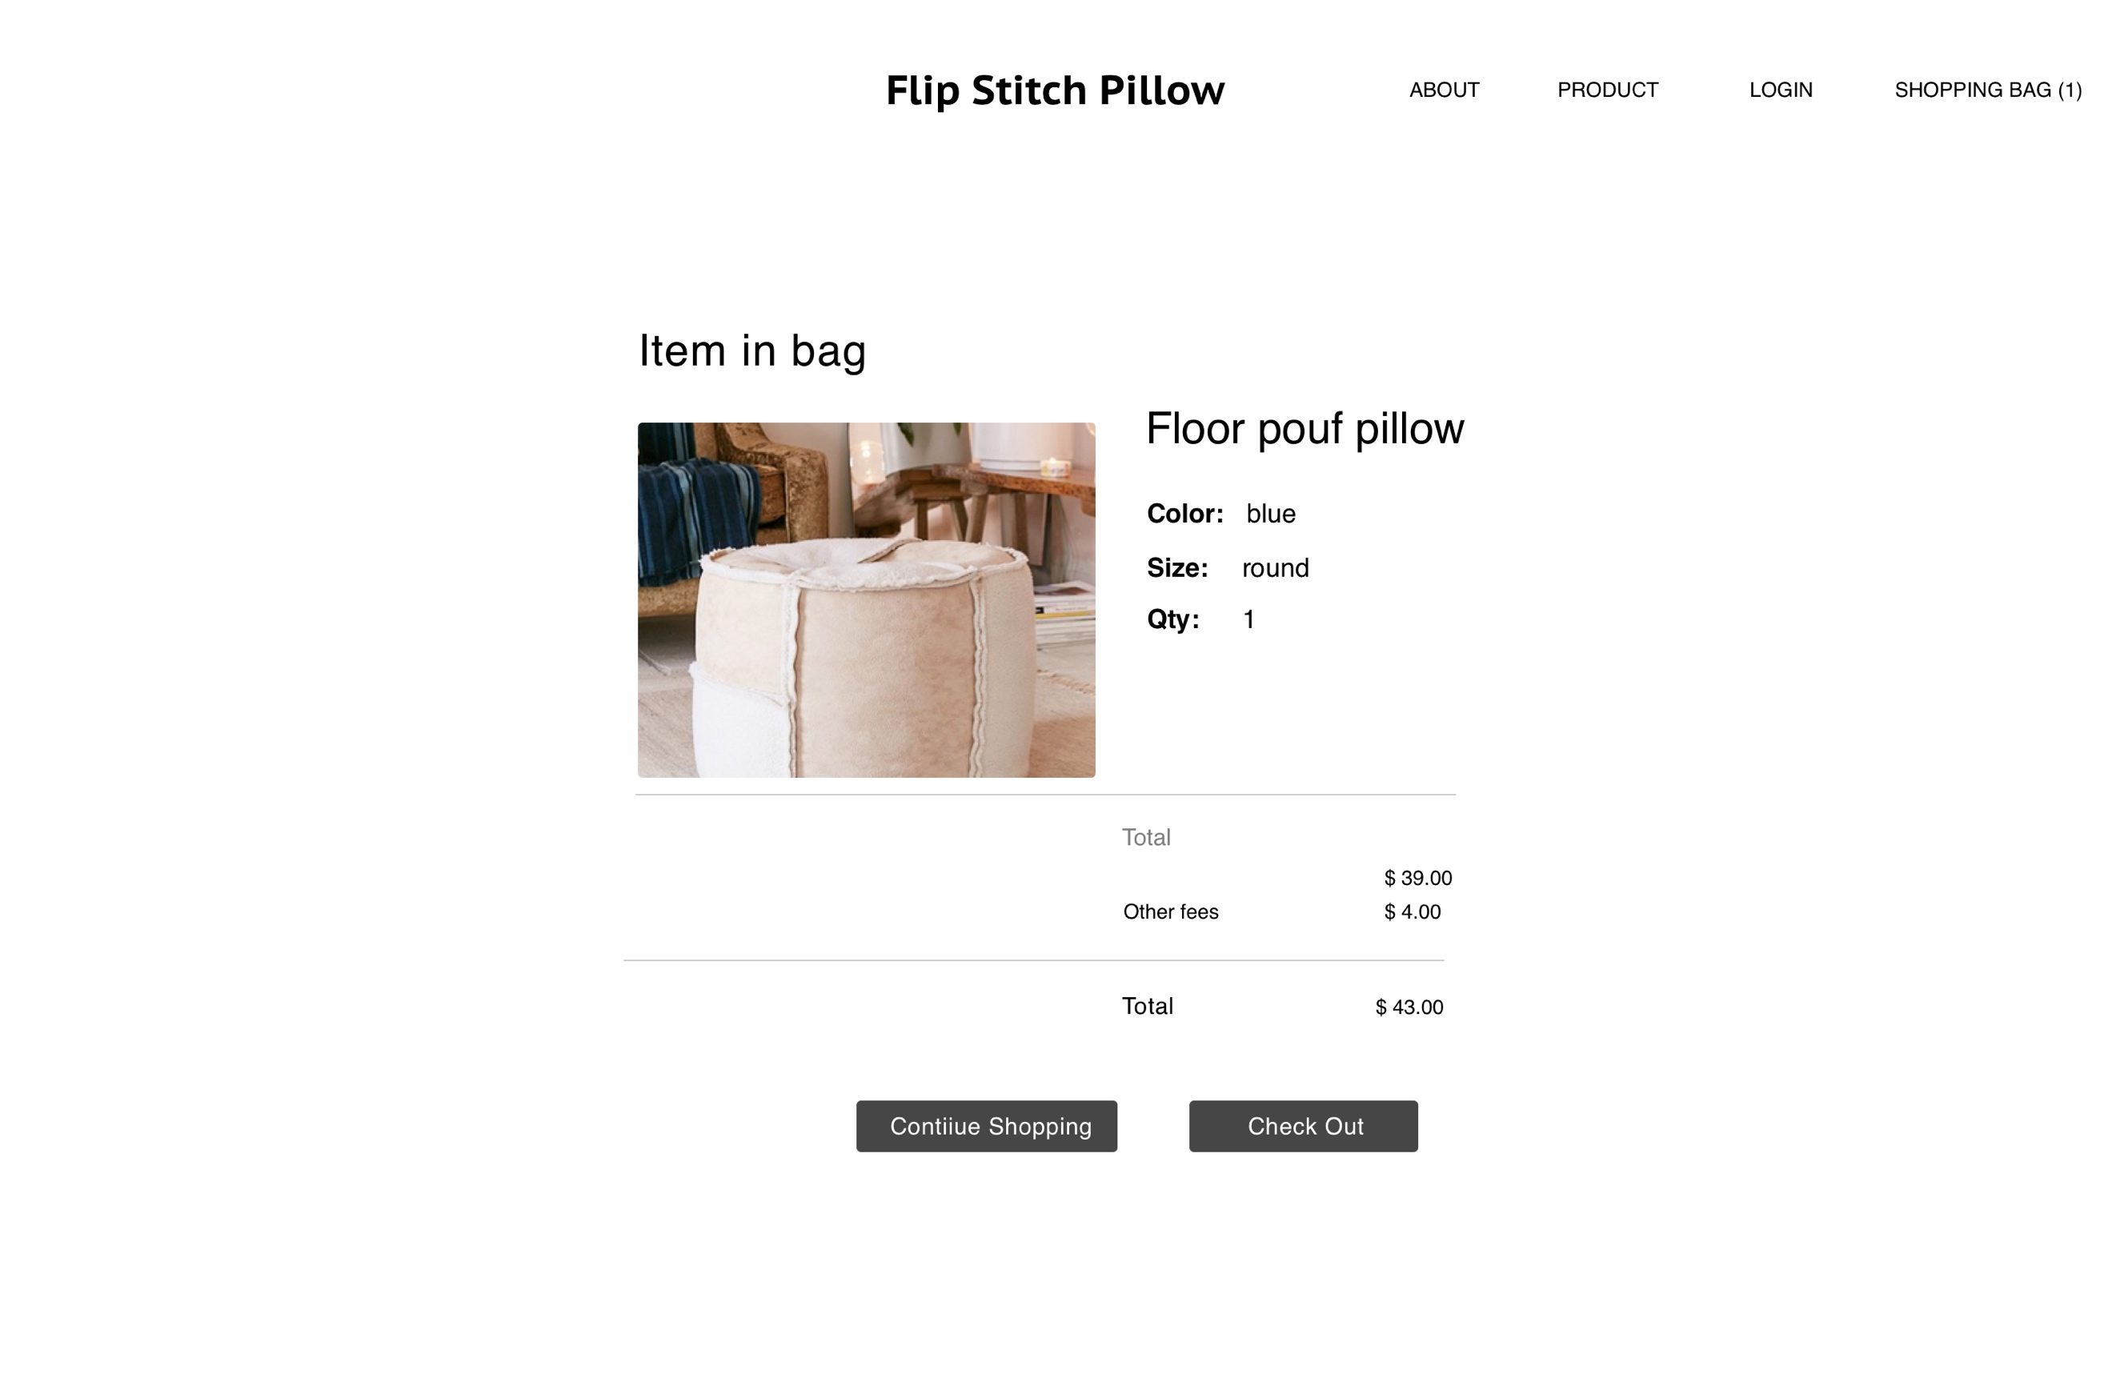

1. High-fidelity prototype of product detail page (there is some change from last time)

I made a few changes to the product detail page compared to last assignment. I decided to let users to choose shape through a dropdown menu instead of buttons, same as choosing quantity to keep everything consistent. I also replaced the “checkout” button with “Add to wishlist” since there is a wishlist feature. Below the action buttons is a carousel showing similar items.

